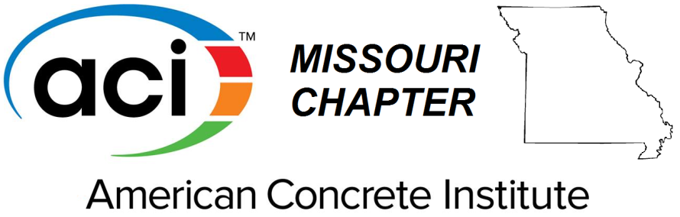

2015-2016 Honorary
Abdeldjelil "DJ" Belarbi
Graduate Scholarship
PURPOSE: To honor long-time ACI Missouri member and Missouri S&T faculty Dr. DJ Belarbi by promoting the development of future engineers, contractors and architects the ACI Missouri Chapter has established the Honorary DJ Belarbi Graduate Scholarship Award. The annual award will provide financial assistance for graduate students pursuing a course of study in the field of concrete design, materials, or construction.
ELIGIBILITY: To receive consideration, a student must be currently enrolled or accepted into a graduate program at an institution located within the boundaries of the ACI Missouri Chapter with a course of study related to concrete materials, design, or construction. During the award year, the student should be enrolled in at least three academic credits per semester/quarter.
CRITERIA: The following criteria must be met by the applicant prior to receiving the award but not necessarily at the time of application:
- Possess a bachelor’s degree from a higher education institution.
- Be accepted or currently enrolled for graduate study at a college or university in a program in the area of concrete where design, materials, construction are offered.
- Maintain status as a full time student during the entire scholarship year.
SUBMISSION: A completed, typewritten application package must be received by the Student Activities Committee, Missouri ACI Chapter by 5pm Friday, March 6th. The package shall include the following:
  - Complete application form (attached below).
  - Undergraduate and graduate transcripts. An unofficial transcript from your current institution is sufficient if it shows all credit from other institutions you have attended.
  - Letter of enrollment or acceptance in a graduate program from an institution located within the ACI Missouri Chapter district.
  - Two letters of recommendation addressing potential for growth, character, leadership capacity, and career interest. One should be from a faculty member. Recommendations must be submitted directly to the ACI Missouri Chapter.
SELECTION OF AWARD RECIPIENTS: Upon receipt of all applications by the deadline of 5pm, Friday, March 6th, the Student Activities Committee shall review the applications. Those applicants who have satisfactorily completed the application will be considered for the award by a three-member, ad-hoc Committee, approved by the board of directors and chaired by the past president of ACI, Missouri Chapter. Selection is based upon academic achievement and awards, relevant experience, quality of application including writing skills, and displayed interest in concrete.
NUMBER, AMOUNT AND PAYMENT OF AWARD: The ACI Chapter will present up to two (2) $2500 scholarship awards. Awards will be announced at the annual meeting of the ACI Missouri Chapter held in conjunction with the Missouri Concrete Conference in Rolla, MO at noon on March 31st, 2015 . All winners and their advisors will receive complementary tickets to this meeting and are encouraged to attend. Payment will be made in two installments at the beginning of Fall and Winter semesters of the award year. If the student fails to provide proof of registration for graduate study for each of those semesters, the award will be forfeited.
APPLICATION
Due: Friday, March 6th , 2015
AMERICAN CONCRETE INSTITUTE – MISSOURI CHAPTER GRADUATE SCHOLARSHIP AWARD
PERSONAL INFORMATION
NAME:
ADDRESS:
TELEPHONE: | EMAIL
HIGHER EDUCATION
INSTITUTION | DATES ATTENDED | CREDIT HOURS | DEGREES AWARDED AND DATE
GRADUATE STUDY
Institution: | Location:
Date of Admission: | Period of Study:
Degree Expected: | Major | Minor
Previous MO-ACI graduate scholarship? Yes , No If yes, when?:

- What reasons do you believe support your application for this award? (Financial need is not an important criterion.)
- What is your background in the field of concrete? Of particular interest is your experience in design, materials, construction, and/or research. Include a summary of your work experience and accomplishments.

- What is your plan for continuing your education? What goals have you established for your education?

- What specific work relating to concrete, such as design, materials, construction, or research, will you pursue during your graduate work?

- What will your program of study be during the year of this award? (List coursework and research)
REFERENCES
List the names of two people from whom you have requested recommendations be emailed or mailed to the ACI-MO Chapter at the address below.
NAME | TITLE | EMPLOYER | ADDRESS

I certify that the information contained in this application is true and that I have answered all of the questions to the best of my ability. I agree that I will notify the ACI Missouri Chapter immediately when my educational program is interrupted or changed in any manner that may jeopardize the intent of the award. I further agree that I will accept the award only as long as I successfully pursue the graduate study program I have described above and for which the reward was made.
Signature: ____________________________ Date: _________________

RETURN COMPLETED APPLICATION PACKAGE BY Friday, March 6th, 2015 TO
dane.shaw@jacobs.com (PREFERED SUBMISSION METHOD)

or

Dane M. Shaw
Jacobs Engineering
501 N. Broadway
Saint Louis, MO 63102

Applicants are encouraged to submit applications electronically. Please make every attempt to submit in one email. Letters of reference should be sent directly either electronically or by mail.

