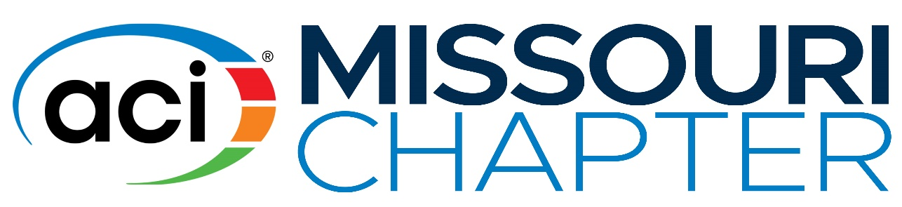
2020-2021 Honorary
Luke and Billie Snell
Undergraduate Scholarship
PURPOSE: To honor long-time chapter members Luke Snell and Billie Snell by promoting the development of future engineers, construction managers, and architects the ACI Missouri Chapter has established the Honorary Luke and Billie Snell Undergraduate Scholarship Award. The annual award will provide financial assistance for undergraduate students with an interest in careers in concrete design, materials, or construction.
ELIGIBILITY: To receive consideration, a student must be currently enrolled or accepted into an undergraduate program at an institution located within the boundaries of the ACI Missouri Chapter. During the award year, the student should be enrolled in at least twelve academic credits per semester/quarter.
CRITERIA: The following criteria must be met by the applicant prior to receiving the award but not necessarily at the time of application:
- Be currently enrolled for undergraduate study at a college or university engineering, construction management, architecture or materials department.
- Maintain status as a full time student during the entire scholarship year.
SUBMISSION: A complete, typewritten application package must be received by the Student Activities Committee, Missouri ACI Chapter by 5pm FRIDAY, APRIL 3, 2020. The package shall include the following:
  - Complete application form (attached below).
  - Undergraduate transcripts. An unofficial transcript from your current institution is sufficient if it shows all credit from other institutions you have attended. Include high school transcript if you have fewer than 60 hours of college credit.
  - Letter of enrollment or acceptance from an institution located within the ACI Missouri Chapter district.
  - Two letters of recommendation addressing potential for growth, character, scholarship, and interest in concrete. At least one letter should be from a faculty member. Recommendations must be submitted directly to the ACI Missouri Chapter.
SELECTION OF AWARD RECIPIENTS: Upon receipt of all applications by the deadline of 5pm, Friday, April 3, 2020, the Student Activities Committee shall review the applications. Those applicants who have satisfactorily completed the application will be considered for the award by a three-member, ad-hoc Committee, approved by the Board of Directors and chaired by the Past President of ACI, Missouri Chapter. Selection is based upon academic achievement and awards, relevant experience, quality of application including writing skills, and displayed interest in concrete.

NUMBER, AMOUNT AND PAYMENT OF AWARD: The ACI Chapter will present two (2) awards of $5,000 each. Awards will be announced at the annual meeting of the ACI Missouri Chapter held in conjunction with the Missouri Concrete Conference in Rolla, MO at noon on TUESDAY MAY 5, 2020. All winners and a guest will receive complementary tickets to this meeting. Selected recipients of the Luke and Billie Snell Scholarship are required to attend the May 5th Annual Meeting and Luncheon of the Missouri Chapter of ACI to be held in conjunction with the Missouri Concrete Conference in Rolla, MO. Payment will be made in two installments at the beginning of Fall and Winter Semesters of the award year. If the student fails to provide proof of registration for study for each of those semesters, the award will be forfeited.

APPLICATION
Due: Friday, April 3, 2020
AMERICAN CONCRETE INSTITUTE – MISSOURI CHAPTER LUKE AND BILLIE SNELL UNDERGRADUATE SCHOLARSHIP AWARD

PERSONAL INFORMATION
NAME: Click or tap here to enter text.
ADDRESS:Click or tap here to enter text.
TELEPHONE: Click or tap here to enter text. | EMAIL Click or tap here to enter text.
EDUCATION
INSTITUTION | DATES ATTENDED | CREDIT HOURS | GRADUATION DATE  (If Applicable)
High School  Click or tap here to enter text. | Click or tap here to enter text. | Click or tap here to enter text. | Click or tap here to enter text.
College  Click or tap here to enter text. | Click or tap here to enter text. | Click or tap here to enter text. | Click or tap here to enter text.
 | Click or tap here to enter text. |  | Click or tap here to enter text.
 | Click or tap here to enter text. |  | Click or tap here to enter text.
COLLEGE STUDY
Institution: Click or tap here to enter text. | Location: Click or tap here to enter text.
Date of Admission: Click or tap here to enter text. | Period of Study: Click or tap here to enter text.
Degree Expected: Click or tap here to enter text. | Major Click or tap here to enter text. | Minor Click or tap here to enter text.
Previous MO-ACI scholarship winner? Yes ☐, No ☐ If yes, when?: Click or tap here to enter text.☐

Click or tap here to enter text.
- Describe how you developed an interest in concrete. What aspects of concrete do you find most interesting? (Answers cannot exceed allotted space)
Click or tap here to enter text.
- What is your experience with concrete? Include any practical experience gained through work, school, or personal activities.

Click or tap here to enter text.
- What courses relating to concrete have you taken or do you intend to take while in college? Include courses where only a portion of the curriculum is concrete-related.
Click or tap here to enter text.
- What careers are you interested in pursuing after you graduate? How do you feel that your chosen coursework will help you achieve your goals?

REFERENCES
List the names of two people from whom you have requested recommendations be email or mailed to the ACI-MO Chapter at the address below.
NAME | TITLE | EMPLOYER | ADDRESS
Click or tap here to enter text. | Click or tap here to enter text. | Click or tap here to enter text. | Click or tap here to enter text.
Click or tap here to enter text. | Click or tap here to enter text. | Click or tap here to enter text. | Click or tap here to enter text.

I certify that the information contained in this application is true and that I have answered all of the questions to the best of my ability. I agree that I will notify the ACI Missouri Chapter immediately when my educational program is interrupted or changed in any manner that may jeopardize the intent of the award. I further agree that I will accept the award only as long as I successfully pursue the program of study I have described above and for which the reward was made.
Signature: ____________________________ Date: _________________

SUBMITTAL INSTRUCTIONS
Please return your completed application package by FRIDAY, APRIL 3, 2020.

Applicants are required to submit applications electronically via email to dshaw@ameren.com. Please make every attempt to submit in one email. Letters of reference should be sent directly from the referring individual as no reference letters will be accepted from applicants.

For questions about submittals, please contact Dane Shaw at the above email or by phone at 314-957-3253.

